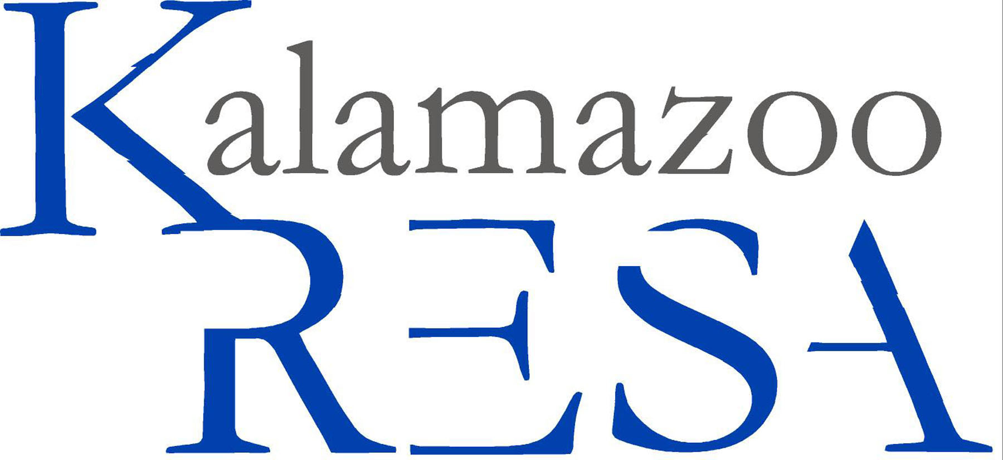
Kalamazoo Regional Educational Service Agency
Job Description

Job Title: EFA Coordinator
Reports To: Director of EFA
FLSA Status: Exempt
Prepared By: Human Resources
Approved By: N/A
Prepared Date: 07/2011
Last Revised Date: 07/2011

Summary:
EFA Coordinator is responsible for providing administrative supervision and support for Arts for All and operational support for EFA Excellence in the Arts programs at the Epic Center. Those essential duties and responsibilities include but are not limited to the following.

Essential Duties and Responsibilities:
Performing Artists and Cooperating Educators (PACE): Administer all operational details including:
- Resident Artist assignments
- Supervision of instruction (assuming appropriate credentials/experience)
- Recruitment of artistic staff
- Marketing of program to schools
- Professional development opportunities for artists and educators
- Budget
- Artist employment agreements and payroll notifications
- PACE Consortium Events each semester at the Epic Center
- Communication and correspondence with building administrators and cooperating educators
- Coordinate student attendance at EFA Presents events
- Regular and consistent attendance
- Other administrative support as needed

EFA Presents: Coordinate all budget and operational details of EFA Presents series including:
- Coordinating schedules with schools and presenting venues/organizations
- Developing promotional materials and marketing of events and billings to schools
- Manage production requirements/technical riders with presenting organizations and venues
- Develop travel and housing arrangements for artists
- Coordinate busing and house management with schools and venues
- Coordinate offerings and schedules with other EFA programs especially Aesthetic Education/Lincoln Center program
- Other administrative support as needed

Page 2 Job Title: EFA Coordinator

Epic Center Operations: Provide day-to-day onsite administrative support for all EFA operational programs at the Epic Center including:
- Staff supervision (excepting supervision of instruction) and support
- Coordinating production/technical support for EFA events
- Scheduling of rooms, keys, parking, custodial services etc.
- Maintain collaborative relationships with Arts Council and Epic Center tenants
- Assist students and EFA staff with student transportation questions
- Other administrative support as needed

Grants: Research, develop, write, submit and administer all EFA and EFA consortium grant requests (excepting Gilmore Foundation) especially to Michigan Council of Arts.
- Develop prospects and submit grant proposals to other funding sources in collaboration with EFA director

Publications and Communications: Maintain KRESA/EFA website in collaboration with KRESA Webmaster including:
- EFA calendar
- Artist/staff profiles
- Other aspects as needed
- Generate and review all other EFA media/publication materials as needed

Aesthetic Education: Provide administrative support and assistance in the implementation of the EFA Aesthetic Education program including developing in consultation with AE Program Coordinator:
- Performance schedules
- Teaching Artist assignments
- Training and professional development workshops
- Budgets
- Other administrative details as needed

Other Duties as Assigned: The EFA Coordinator position is designed and located within KRESA/EFA to provide administrative support and coordination for both all EFA initiatives detailed above as well as new and emerging opportunities which develop in EFA over time. Some are short term; others may become ongoing or sustained over time.

Must have knowledge of and comply with the policies and procedures contained in the Kalamazoo RESA handbook.

Education and/or Experience:
BA from four-year college or university and one to two years related professional experience or training; or equivalent combination of education and experience.

Certificates, License, Registration:
Maintain current state licensure in area of discipline.

Page 3 Job Title: EFA Coordinator

Other Skills and Abilities:
High level written and oral communication skills
Ability to develop and maintain an effective network of collegial, collaborative relationships with EFA administrators, staff and colleagues in the arts and education community
Ability to set priorities, be organized and a self-starter, develop administrative structures and procedures where needed consistent with KRESA/EFA policies
Exhibit attitude of appreciation and respect for student artistic and educational development
Ability to understand and connect the resources and needs of the arts and educational communities
Ability to generate, read, write, analyze and interpret data and reports
Efficiently and effectively use computer and software resources
Delegate work assignments where appropriate
Mentor development of EFA professional staff
Keep director abreast of developments in program status
Ability to anticipate and resolve problems creatively and imaginatively
Ability to write reports, correspondence and procedural documents
Effectively present information to groups and engage with diverse audiences
Develop strategies to articulate and achieve short and long range program goals
Maintain confidentiality
Complete hours of work as necessary to reach goals
Adapt to frequent changes in the work environment
Practice safe work habits using equipment and materials properly

Supervisory Responsibilities:
Directly supervise 20-30 Artists or Instructors of Art.

Physical Demands:
Reasonable accommodations may be made to enable individuals with disabilities to perform the essential functions. The employee is frequently required to reach with arms and hands, stand, walk and sit. The employee must frequently lift and/or move up to ten pounds and occasionally lift and/or move up to 25 pounds. Specific vision abilities required by this job include close vision, depth perception and ability to adjust focus.

Work Environment:
The noise level in the work environment is usually quiet.

The employee shall remain free of any alcohol or nonprescribed controlled substance in the workplace throughout his/her employment in the District.

It is the policy of Kalamazoo Regional Educational Service Agency that no discriminating practices based on gender/sex, sexual orientation, race, religion, height, weight, color, age, national origin, disability or any other status covered by federal, state or local law be allowed during any program, activity, service or in employment. The following positions at Kalamazoo RESA have been designated to handle inquiries regarding the nondiscrimination policy. Human Resources Director, Tom Zahrt; Assistant Superintendents: Margaret McGlinchey & Laurie Montgomery. Contact information: 269-250-9200, 1819 E. Milham Avenue, Portage, MI 49002.

